7.2 (15pts):

Consider the experiment described in Problem 6.1. Analyze this experiment assuming that each replicate represents a block of a single production shift.

An engineer is interested in the effects of cutting speed (A), tool geometry (B), and cutting angle (C) on the life (in hours) of a machine tool. Two levels of each factor are chosen, and three replicates of a 2k factorial design are run. The results are as follows:

Table 1: Tool life data

|  |  |  |  |  |  |
| --- | --- | --- | --- | --- | --- |
|  | Shift | Cutting Speed | Tool Geometry | Cutting Angle | Life Hours |
| 1 | 1 | -1 | -1 | -1 | 22 |
| 2 | 2 | -1 | -1 | -1 | 31 |
| 3 | 3 | -1 | -1 | -1 | 25 |
| 4 | 1 | 1 | -1 | -1 | 32 |
| 5 | 2 | 1 | -1 | -1 | 43 |
| 6 | 3 | 1 | -1 | -1 | 29 |
| 7 | 1 | -1 | 1 | -1 | 35 |
| 8 | 2 | -1 | 1 | -1 | 34 |
| 9 | 3 | -1 | 1 | -1 | 50 |
| 10 | 1 | 1 | 1 | -1 | 55 |
| 11 | 2 | 1 | 1 | -1 | 47 |
| 12 | 3 | 1 | 1 | -1 | 46 |
| 13 | 1 | -1 | -1 | 1 | 44 |
| 14 | 2 | -1 | -1 | 1 | 45 |
| 15 | 3 | -1 | -1 | 1 | 38 |
| 16 | 1 | 1 | -1 | 1 | 40 |
| 17 | 2 | 1 | -1 | 1 | 37 |
| 18 | 3 | 1 | -1 | 1 | 36 |
| 19 | 1 | -1 | 1 | 1 | 60 |
| 20 | 2 | -1 | 1 | 1 | 50 |
| 21 | 3 | -1 | 1 | 1 | 54 |
| 22 | 1 | 1 | 1 | 1 | 39 |
| 23 | 2 | 1 | 1 | 1 | 41 |
| 24 | 3 | 1 | 1 | 1 | 47 |

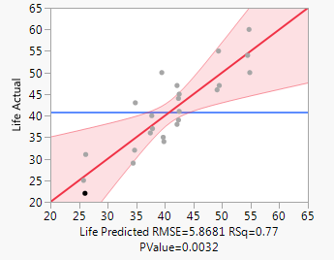

Figure : Actual by predicted

Table : Effect summary

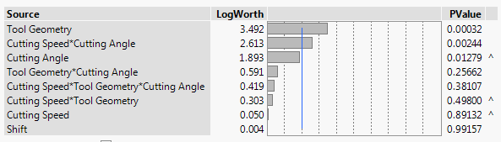

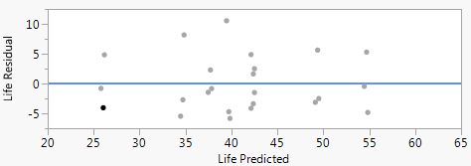

Figure : Residual plot

7.5 (15pts):

Consider the data from the first replicate of Problem 6.7. Construct a design with two blocks of eight observations each with ABCD confounded. Analyze the data.

An experiment was performed to improve the yield of a chemical process. Four factors were selected, and two replicates of a completely randomized experiment were run. The results are shown in the following table:

Table 3: Chemical process yield experiment data

|  |  |  |  |  |  |  |
| --- | --- | --- | --- | --- | --- | --- |
|  | Block | A | B | C | D | Yield |
| 1 | Block 2 | -1 | -1 | -1 | -1 | 90 |
| 2 | Block 1 | 1 | -1 | -1 | -1 | 74 |
| 3 | Block 1 | -1 | 1 | -1 | -1 | 81 |
| 4 | Block 2 | 1 | 1 | -1 | -1 | 83 |
| 5 | Block 1 | -1 | -1 | 1 | -1 | 77 |
| 6 | Block 2 | 1 | -1 | 1 | -1 | 81 |
| 7 | Block 2 | -1 | 1 | 1 | -1 | 88 |
| 8 | Block 1 | 1 | 1 | 1 | -1 | 73 |
| 9 | Block 1 | -1 | -1 | -1 | 1 | 98 |
| 10 | Block 2 | 1 | -1 | -1 | 1 | 72 |
| 11 | Block 2 | -1 | 1 | -1 | 1 | 87 |
| 12 | Block 1 | 1 | 1 | -1 | 1 | 85 |
| 13 | Block 2 | -1 | -1 | 1 | 1 | 99 |
| 14 | Block 1 | 1 | -1 | 1 | 1 | 79 |
| 15 | Block 1 | -1 | 1 | 1 | 1 | 87 |
| 16 | Block 2 | 1 | 1 | 1 | 1 | 80 |

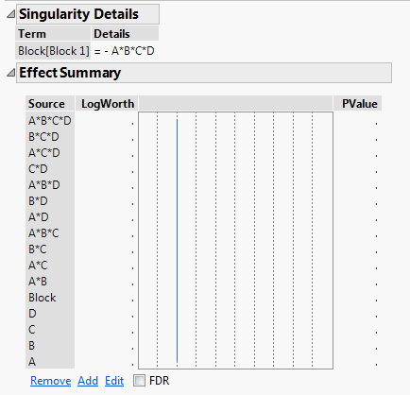

7.6 (15pts):

Repeat Problem 7.5 assuming that four blocks are required. Confound ABD and ABC (and consequently CD) with blocks.